**COMPANY NETWORK DESIGN & IMPLEMENTATION Using Packet Tracer**

A trading company Centre has 600 staff. A building has been identified but has no network. This means that before they can make to move out, new network service needs to be designed and implemented in the new building.

The building is expected to have three floors with two departments in each;

1. First Floor (Sales and Marketing & Human Resource and Logistics)
2. Second Floor (Finance and Accounts, Administrator and Public Relations Department)
3. Third Floor(ICT, Server Room)

**Requirements:**

1. Use Packet tracer to design and implement the network solution.
2. Use hieratical model providing redundancy at every layer (2 routers and two multilayer switches are expected to used to provide redundancy)
3. The network is also expected to connected to at least two ISP’s to provide redundancy and each router to the connected two ISP’s.
4. Each department is required to have a wireless network for the users.
5. Each department should be in a different VLAN and in different subnetwork.
6. Provided a base network of 172.16.1.0 carry out subnetting to allocate he correct number of IP address to each department.
7. The company network is connected to the static public IP address 195.136.17.0/30, 195.136.17.8/30, 192.168.17.12/30 connected to the two internet providers.
8. Configure basic device settings such as Hostnames, console password, enable password, banner message, disable IP domain lookup.
9. Devices in all departments are required to communicate with each other with the respective multilayer switch configured for inter-vlan routing.
10. The Multilayer switches are expected to carry out both routing and switching functionalities thus will be assigned IP address.
11. All devices in the network are expected to obtain IP address dynamically from the dedicated DHCP servers located at the server room.
12. Devices in the server room are to be allocated IP address statically.
13. Use OSPF as the routing protocol to advertise both on the routers and Multilayer Switches.
14. Configure SSH in all routers and layer 3 Switches for remote login.
15. Configure port-security for the finance and Accounts department to allow only one device to connect to a switchport, use sticky method to obtain mac-address and violation mode shutdown.
16. Configure PAT to use to the Respective outbound router interface IPv4 address, implement the necessary ACL rule.
17. Test communication, ensure everything configured is working as expected.

IP Addressing:

Base Network : 172.16.1.0

|  |  |  |  |  |
| --- | --- | --- | --- | --- |
| Department | Network Address | Subnet Mask | Host Address Range | Broadcast Address |
| Sales & Marketing | 172.16.1.0 | 255.255.255.128/25 | 172.16.1.1 – 172.16.1.126 | 172.16.1.127 |
| HR and Logistics | 172.16.1.128 | 255.255.255.128/25 | 172.16.1.129 – 172.16.1.254 | 172.16.1.255 |

Second Floor:

|  |  |  |  |  |
| --- | --- | --- | --- | --- |
| Department | Network Address | Subnet Mask | Host Address Range | Broadcast Address |
| Finance & Accounts | 172.16.2.0 | 255.255.255.128/25 | 172.16.2.1 – 172.16.2.126 | 172.16.2.127 |
| Admin & Public Realtions | 172.16.2.128 | 255.255.255.128/25 | 172.16.2.129 – 172.16.2.254 | 172.16.2.255 |

Third Floor:

|  |  |  |  |  |
| --- | --- | --- | --- | --- |
| Department | Network Address | Subnet Mask | Host Address Range | Broadcast Address |
| ICT | 172.16.3.0 | 255.255.255.128/25 | 172.16.3.1 – 172.16.3.126 | 172.16.3.127 |
| Sever Room | 172.16.3.128 | 255.255.255.128/25 | 172.16.3.129 – 172.16.3.254 | 172.16.3.255 |

Between the Routers and Layer 3 Switches:

|  |  |  |  |  |
| --- | --- | --- | --- | --- |
| No | Network Address | Subnet Mask | Host Address Range | Broadcast Address |
| R1-MLSW01 | 172.16.3.144 | 255.255.255.252 | 172.16.3.145 – 172.16.3.146 | 172.16.3.147 |
| R1-MLSW02 | 172.16.3.148 | 255.255.255.252 | 172.16.3.149– 172.16.3.150 | 172.16.3.151 |
| R2-MLSW01 | 172.16.3.152 | 255.255.255.252 | 172.16.3.153 – 172.16.3.154 | 172.16.3.155 |
| R2-MLSW02 | 172.16.3.156 | 255.255.255.252 | 172.16.3.157 – 172.16.3.158 | 172.16.3.159 |

Between the Routers and the ISP’s

Public IP address 195.136.17.0/30, 195.136.17.4/30, 195.136.17.8/30 and 192.136.17.12/30

First Floor:

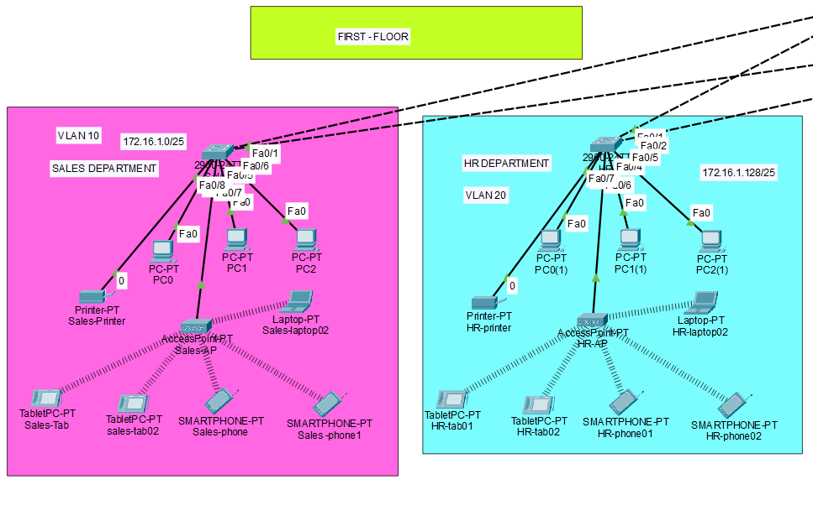

Second Floor:

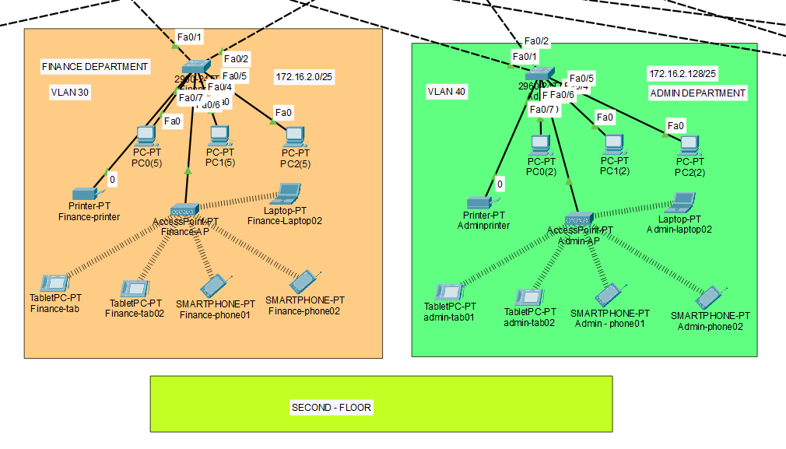

Third Floor:

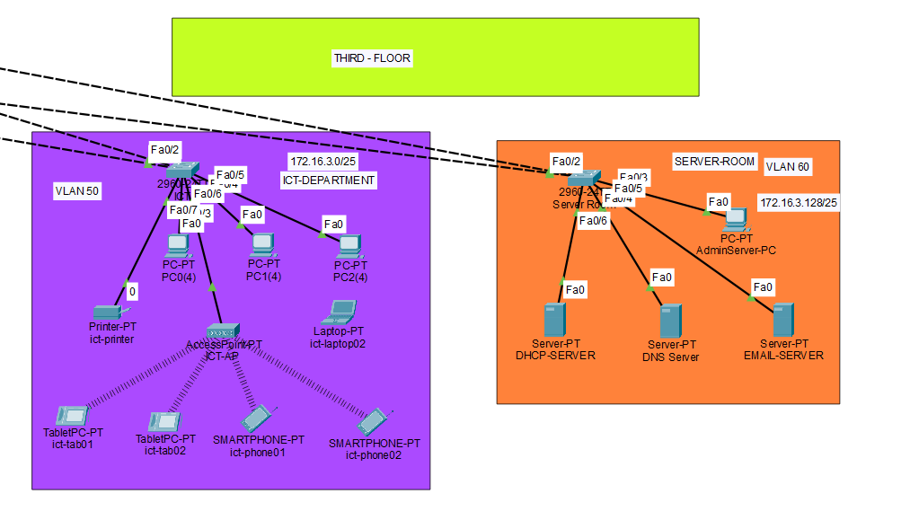

Core layer :

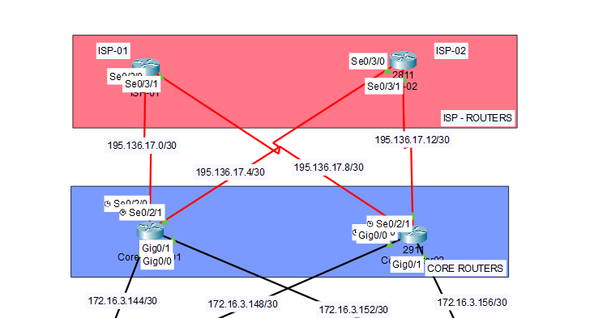

Distribution Layer:

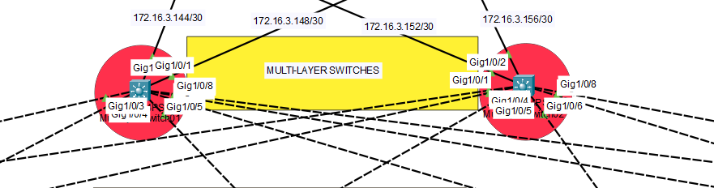

Access Layer:



DHCP SERVER Configuration:

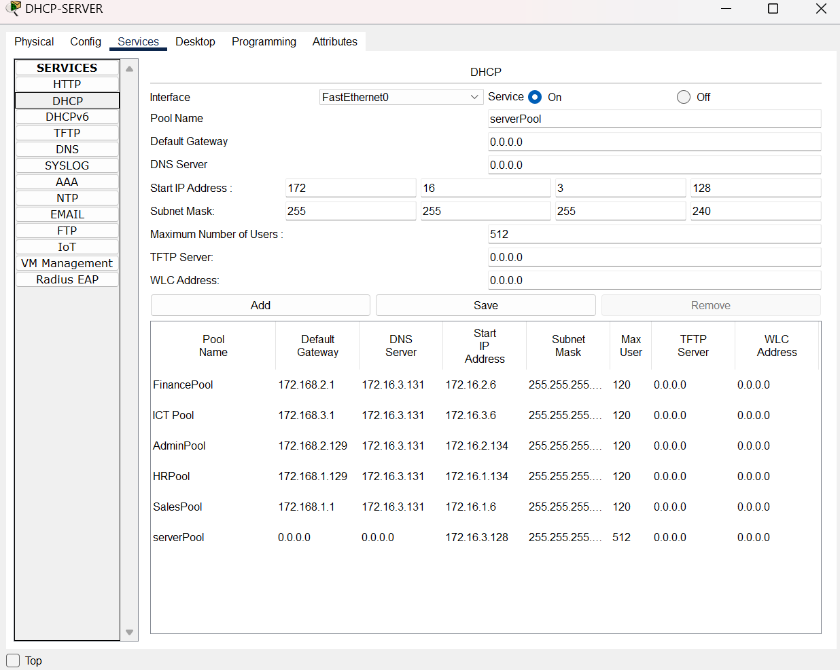

DNS SERVER CONFIGURATION:

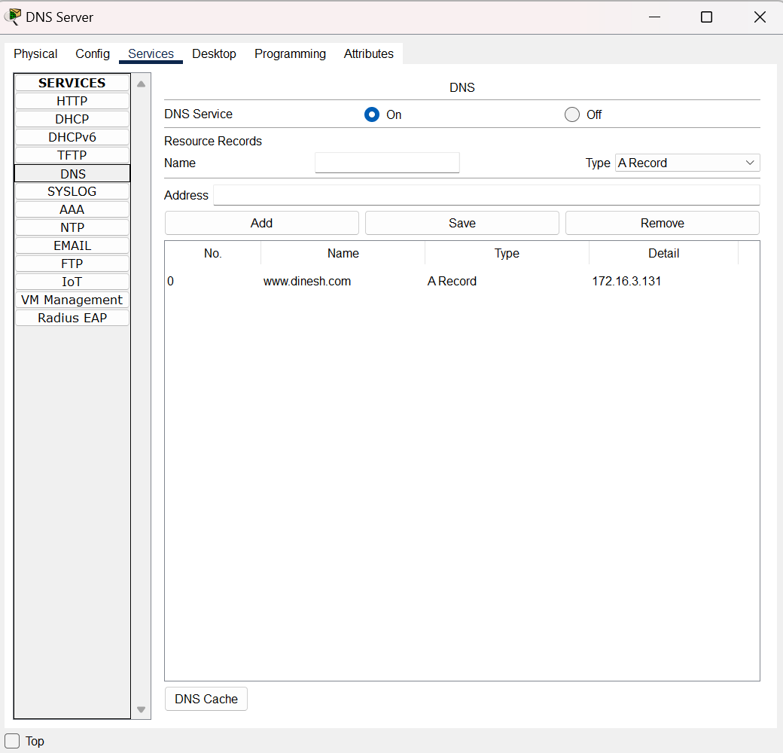

OSPF Configuration:

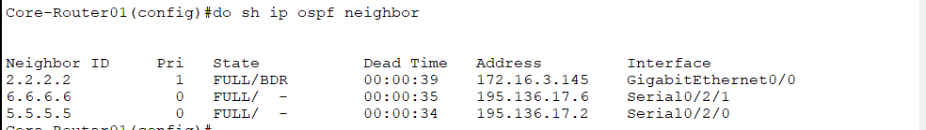

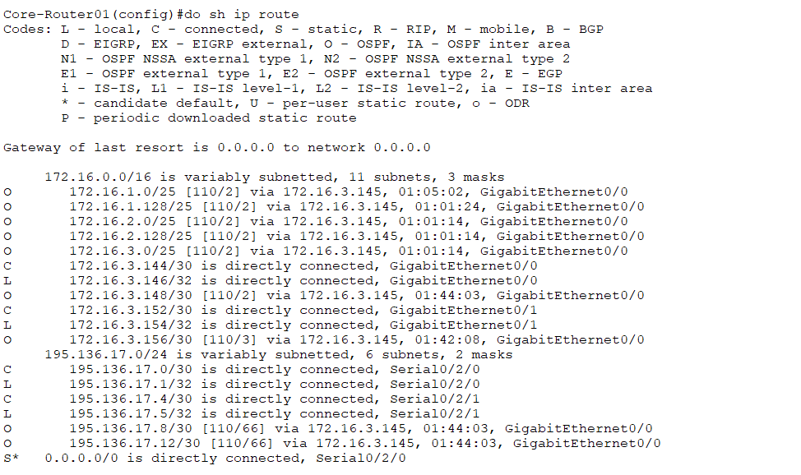

OSPF Configuration in Router 02:

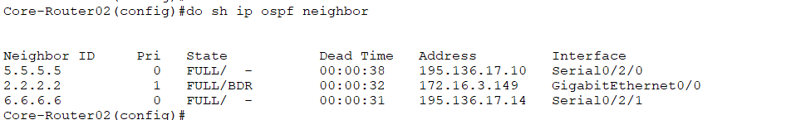

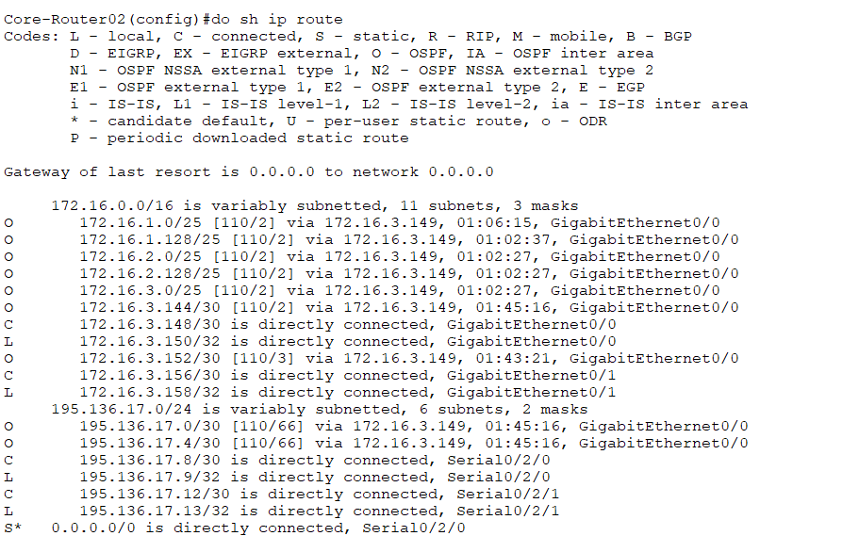

**Enabling security and MOTD:**

en

conf t

hostname Core-Router02

line console 0

password cisco

login

exit

enable password cisco

no ip domain lookup

banner motd #NO UNAUTHORIZED ACCESS!!!!#

service password-encryption

do wr

ip domain name cisco.net

username admin password cisco

crypto key generate RSA

1024

line vty 0 15

login local

transport input ssh

exit

do wr

ip ssh version 2

**VLAN COMMANDS IN DEPARTMENT SWITCHES :**

int range fa0/1-2

switchport mode trunk

ex

vlan 60

name serverroom

vlan 99

name balckhole

ex

int range fa0/3-24

switchport mode access

switchport access vlan 60

ex

int range gig0/1-2

switchport mode access

switchport access vlan 99

ex

do wr

**PORT SECURITY IN FINANCE DEPARTMENT**

Finance(config)#int range fa0/3-24

Finance(config-if-range)#switchport port-security maximum 1

Finance(config-if-range)#switchport port-security mac-address sticky

Finance(config-if-range)#ex

**Trunk configuration in Layer03 Switches:**

int range gig1/0/3-8

switchport mode trunk

vlan 10

name sales

vlan 20

name HR

vlan 30

name Finance

vlan 40

name admin

vlan 50

name ict

vlan 60

name serverroom

ex

do wr

**Configuring Inter-VLAN & Helper address:**

int vlan 10

no sh

ip address 172.16.1.1 255.255.255.128

ip helper-address 172.16.3.130

ex

int vlan 20

no sh

ip address 172.16.1.129 255.255.255.128

ip helper-address 172.16.3.130

ex

int vlan 30

no sh

ip address 172.16.2.1 255.255.255.128

ip helper-address 172.16.3.130

ex

int vlan 40

no sh

ip address 172.16.2.129 255.255.255.128

ip helper-address 172.16.3.130

ex

int vlan 50

no sh

ip address 172.16.3.1 255.255.255.128

ip helper-address 172.16.3.130

ex

int vlan 60

no sh

ip address 172.16.3.129 255.255.255.128

ip helper-address 172.16.3.130

ex

**Configuring NAT and Access List:**

ip nat inside source list 1 int se0/2/0 overload

ip nat inside source list 1 int se0/2/1 overload

access-list 1 permit 172.16.1.0 0.0.0.127

access-list 1 permit 172.16.1.128 0.0.0.127

access-list 1 permit 172.16.2.0 0.0.0.127

access-list 1 permit 172.16.2.128 0.0.0.127

access-list 1 permit 172.16.3.0 0.0.0.127

access-list 1 permit 172.16.3.128 0.0.0.15

int range gig0/0-1

#ip nat inside

#ex

int se0/2/0

ip nat outside

#int se0/2/1

ip nat outside

ex

do sh ip nat translation

ip route 0.0.0.0 0.0.0.0 gig1/0/1

ip route 0.0.0.0 0.0.0.0 gig1/0/2 70

do wr

ip route 0.0.0.0 0.0.0.0 se0/2/0

ip route 0.0.0.0 0.0.0.0 se0/2/0 70

**Result:**

Getting response from Finance department to HR department:

Finance PC 01 – 172.16.2.20

HR PC01 – 172.16.1.142

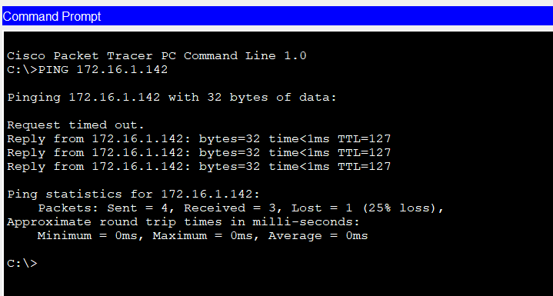

**Getting access from the Core Router from the PC using SSH:**

